Jenkins copy the jobs one server to another server:

Step1: First we need to go Jenkins jobs location then choose the job and zip the job folder as mentioned below.

>>cd /var/lib/jenkins/jobs

zip –r jobname.zip jobname

step2: Now, we need to move the zip file another Jenkins jobs location as mentioned below.

>> scp jobname.zip username@ip: /var/lib/jenkins/jobs

step 3: Now, we need to restart jenkins on new jenkins machine side.

Step 4: Now we need to login the new jenkins machine.

Step 5: Click on manages jenkins

Step 6: click on reload configuration from disk, after click this option pop window appear,click ok shown below second screen shot.

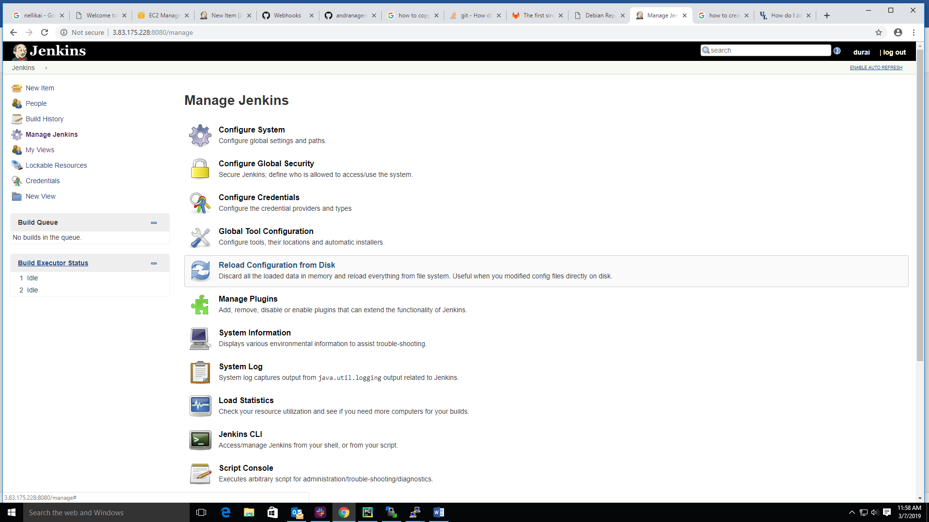

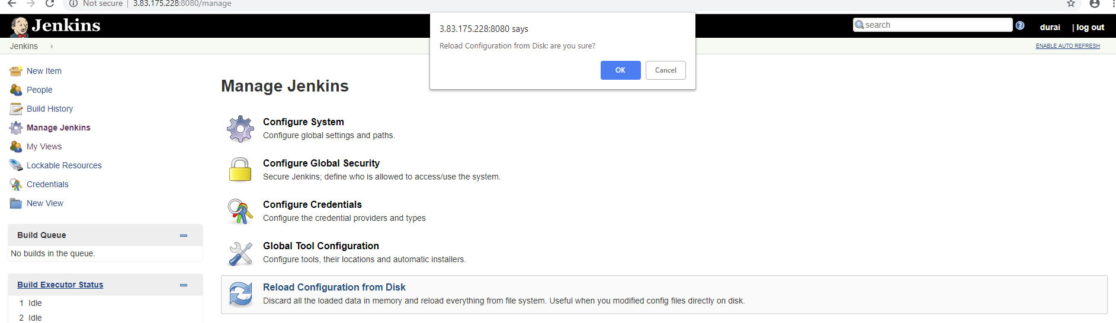

Step 7: After click ok now job will be created and display on jenkins dashboard as shown below screen shot.

